Notice of Annual General Meeting of the
Chartered Institute of Fundraising
(“the Chartered Institute”)

This is Notice that an annual general meeting of the members of the Chartered Institute will be held virtually on Thursday 28th September 2023, 10:30-11:30, via Zoom.

- Welcome & apologies
- To receive the minutes of the Annual General Meeting held on 29 September 2022

- To receive the Chair’s report

- To receive the Treasurer’s report and the Report and Accounts for the twelve months 1 January 2022 to 31 December 2022

- To approve the appointment of Auditors

- To receive the Chief Executive’s report

- Other business

The date of this notice is: 1 September 2023

By order of the Board

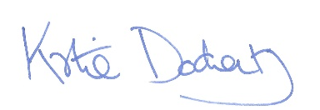
Signed: ………………………
Katie Docherty
Chief Executive

The registered office of the Chartered Institute of Fundraising is:
Canopi, 7-14 Great Dover Street, London SE1 4YR

