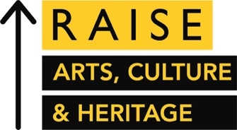
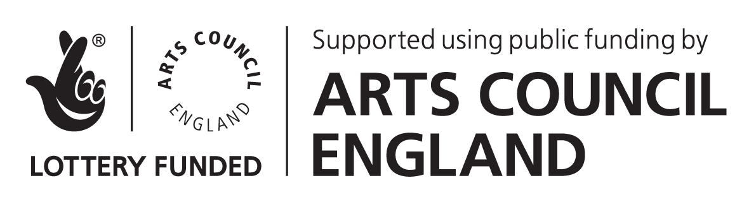

YAF x RAISE 2021/22 MENTORING PROGRAMME
MENTEE APPLICATION FORM
This word document is for drafting purposes only. Once you’re ready to submit your application, please head to our website and input your answers into the online application form. This application form can also be listened to in an audio format, available on our website.
Application Process
Please complete the following form to provide information relating to your career, current role, and interest in this programme, to assist us in matching you with your Mentor. Your responses in section one will be shared with your Mentor once a match has been made, and all other information will be available only to those running the CIoF Cultural Sector Network and Young Arts Fundraisers mentoring programme.

Deadline:
The deadline for application is Monday, 24th May 2021.

We will contact you with the outcome of your application via email by Monday, 7th June 2021.
Section One – Shared Information
Your responses to the following questions will be shared with your Mentor, once a match has been made:
Your name

Your pronouns

Your job title

Your organisation, or enter ‘Freelance’ or ‘Self-Employed’ if applicable

E-mail address

Mobile number

Primary location you work from (City/Town/Borough)

Please upload a PDF copy of your CV
- Document upload option
Please tick to confirm that you meet the eligibility criteria for this programme:
- I am an arts fundraiser
- I am based in, or work for an organization based in England
- I am available for all of the key dates listed in the application guidance
- I have read the application guidance and understand the commitments I would have as a mentee on the programme

Are you solely responsible for managing the fundraising within your organisation?

- Yes
- No

On a scale 1 to 4 (1= NOT confident, 4= VERY confident) how confident do you feel about your fundraising skills?
- 1
- 2
- 3
- 4
If you would like to answer the following 3 questions in an audio or video format (of a maximum of 5 minutes recording for all 3 questions combined) then please paste the link to listen to/view this recording here. An upload to Google Drive, Vimeo, YouTube, SoundCloud, or a similar platform is preferable. Please don’t upload to a service such as WeTransfer as the link may expire before the assessment team gets to it.

Please summarise your main responsibilities in your current role, as well as a list of previous job roles and organisations if applicable (please answer in approximately 250 words).

Please explain why, at this stage in your career, you would benefit from the support of the mentoring programme?
Your ideas about what you would like to address through mentoring may or may not be entirely clear, but you will find it helpful to consider: key goals you would like to achieve, whether short or long term; how would you benefit from the additional support outside of your current network, and the options you could take to reach your goals. Of course, it is understood that your goals may shift throughout the mentoring period (please answer in approximately 250 words).

What do you think the main purpose of mentoring is, and how will it help your career? (please answer in approximately 250 words)

Section 2 - Internal use only
Your responses to the questions below will be available only to those running the CIoF Cultural Sector Network and Young Arts Fundraisers mentoring programme, and will be used as per our Privacy Notice below.

If you need any adjustments to enable you to access and benefit from the mentoring programme, then please include them here. Where your Mentor needs to be aware of these, the information will be confidentially shared with your Mentor once a match has been made.

Please indicate which community or communities you identify with:
- Anyone identifying as Black, Asian or from a Minority Ethnic background
- Anyone identifying as disabled and or D/deaf, including those who are neurodiverse
- Anyone identifying as LGBTQ+
- Anyone self-identifying as early-career arts, cultural & heritage sector fundraisers and/or anyone who is in the first five years of their fundraising career
- Small and medium charities: Organisations with an annual turnover (contributed and earned income) up to £750,000.

Please select your organisation’s annual contributed and earned income:

< £250k £251k -750k £751k - 1million £1- 5 million > £5 million

Skills Questionnaire
The following question is to help you reflect on your priorities so that you can be clear about what you want from the scheme, and to help us match you with Mentors. We will also use the results to evaluate the impact of the mentoring scheme by comparing it with a questionnaire that we’ll send you at the end of the 12-month mentoring period.

Which of the following fundraising skills do you feel you need assistance with? (Tick all that apply)
- Identifying and applying to grant-making trusts and foundations
- Identifying and applying for corporate donations and/or corporate sponsorship
- Identifying and applying for statutory Government funding
- Securing low-level regular donations from individuals
- Cultivating and managing major donors
- Building face to face relationships with donors and making the ‘ask’
- Organising fundraising events
- Defining an effective Case for Support
- Undertaking effective research into the current status of the fundraising marketplace
- Using a variety of different channels to access funds and funders (e.g. Grant applications, mailshots, special events etc.)

Which of the following professional skills do you feel you need assistance with? (Tick all that apply)
- Preparing and delivering a presentation
- Speaking in front of a group of people
- Negotiating effectively
- Expressing ideas clearly and effectively in writing
- Explaining issues or tasks to other people
- Discussing issues with people in more senior roles
- Managing time effectively
- Prioritising tasks and activities effectively

By ticking the box below you confirm you agree to our and Terms and Conditions:

Terms and Conditions

An experienced panel from Young Arts Fundraisers, CIoF Cultural Sector Network and RAISE will be responsible for the pairings, matching Mentees with Mentors based on experience and need for the programme.

To ensure that we are being fair to all of the applicants, any Mentee forms sent beyond the deadline will not be considered for the programme. All of the applications are carefully considered and all applicants will be informed if they are successful or unsuccessful.

The mentoring programme lasts for one year and Mentees are expected to meet with Mentors at least six times over the course of the programme, either in person or over Zoom/telephone. Please make sure that your line manager is aware of the commitment involved in being part of the mentoring programme before submitting an application.

Successful Mentees will receive materials to help prepare for the mentoring experience and a training session at the beginning of the programme.

Privacy Notice

The Chartered Institute of Fundraising of Charter House, 13-15 Carteret Street, London SW1H 9DJ is the Controller.

RAISE: Arts, Culture & Heritage is an Institute of Fundraising programme of support to the professional development of fundraisers working in the arts, culture and heritage sector in England.
The information you provide will be shared with Young Arts Fundraisers for the following purposes:

- To find the best mentor matching for you
- To administrate your attendance to our final mentoring event
- To provide stewardship and support throughout the programme – this may be by phone, email or face to face
- To gain feedback about your mentoring sessions – this may be by phone, email or by hard copy at the final event
- For analysis and research to help us improve our services, event management and to report on the outcomes of the RAISE programme

All information you provide will be kept confidential and used solely for the purposes stated above. At the end of the mentoring process, your personal information will be returned to the Institute of Fundraising.

We will keep your personal data in relation to the mentoring programme until 30 June 2022 (3 months after the end of RAISE) unless you ask us to remove it before then.

You can access the Institute of Fundraising’s full Privacy Policy here:

Thank you for taking the time to complete this application form.

The deadline for applications is Monday, 24th May 2021

We will contact you with the outcome of your application via email by Monday, 7th June 2021.

